**TestDataDB Macro Manual**

* Step 1 – Click UseCase Refresh Button to get Use Case Validations based on the no of used row count

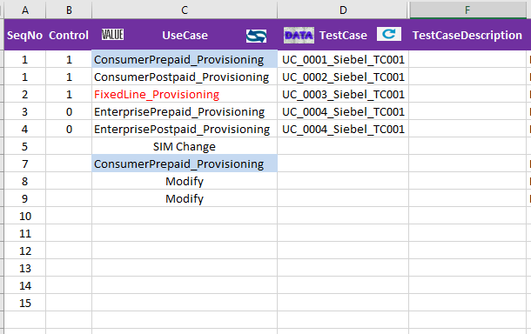

* Step 2- After Selecting Expected Use Cases click on the Data button on the Test Case Header to fetch the Appropriated Field Names with auto populated mandatory 3 Fields and Field Name Validation for the other Field Names

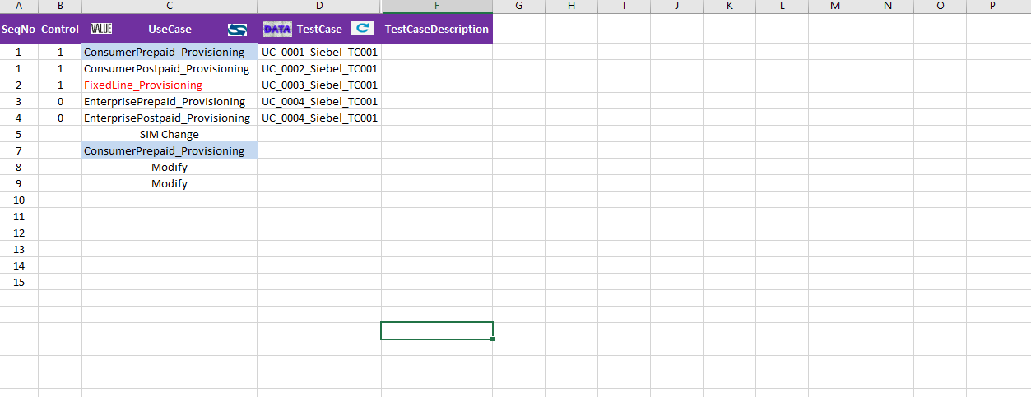

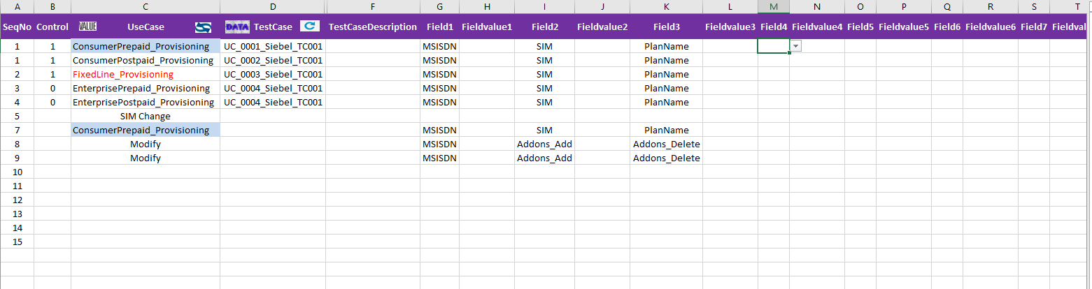

* Step 3 – Click the Value button to get the corresponding Field Value Validations on which Field Value can be provided as expected

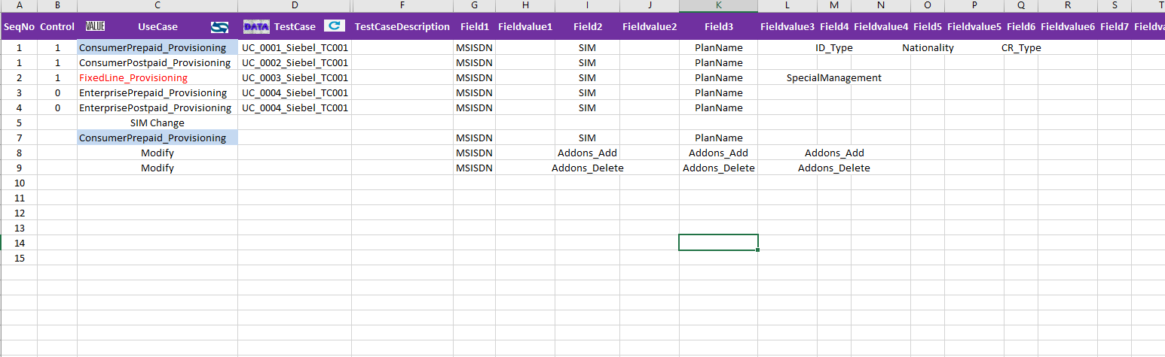

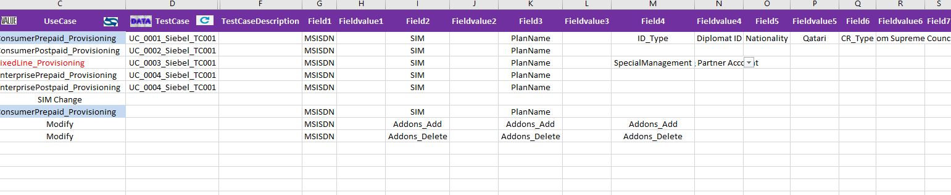

* Step 4 – On Providing the expected values and clicking on Refresh button in Test Case Field Header

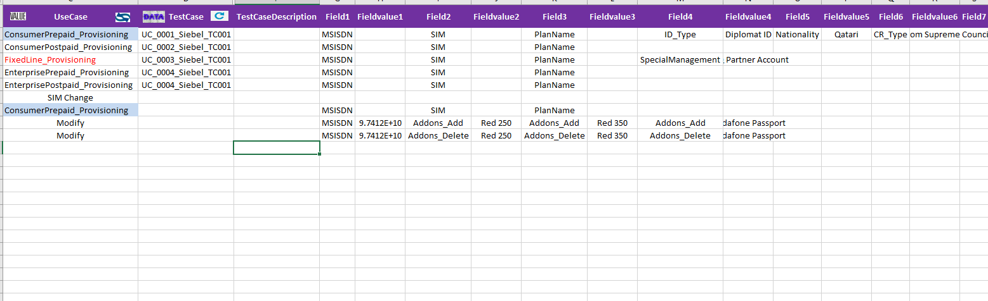

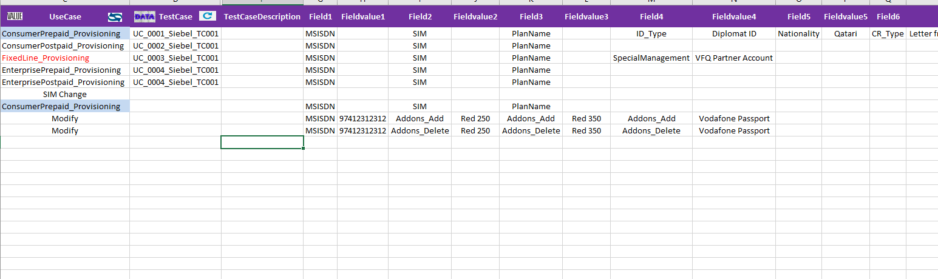

Data Field (Hidden) is generated as expected with fetching appropriate addons from hidden Addons sheet and the hidden Data displays as below

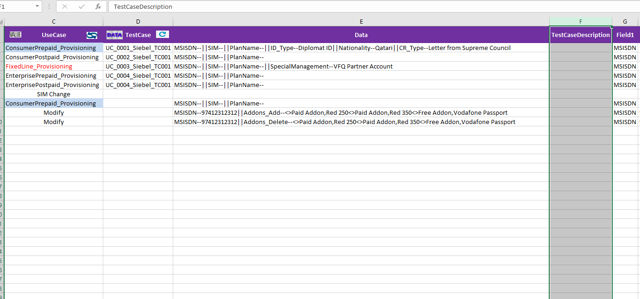

* Note1: Field Values are provided only if FieldName is available in DataValue Sheet which is Hidden with the Macro
* Note2: Addons with the respective Addon tab will be fetched with Addons Sheet which is Hidden with the Macro
* Auto Formating and Auto Fitting is also applied.